Parameters in Postman

Query Parameter

Below API has two query parameters ‘maxResults’ and ‘key’.

When the value of maxResults is 1 only one message id is displayed.

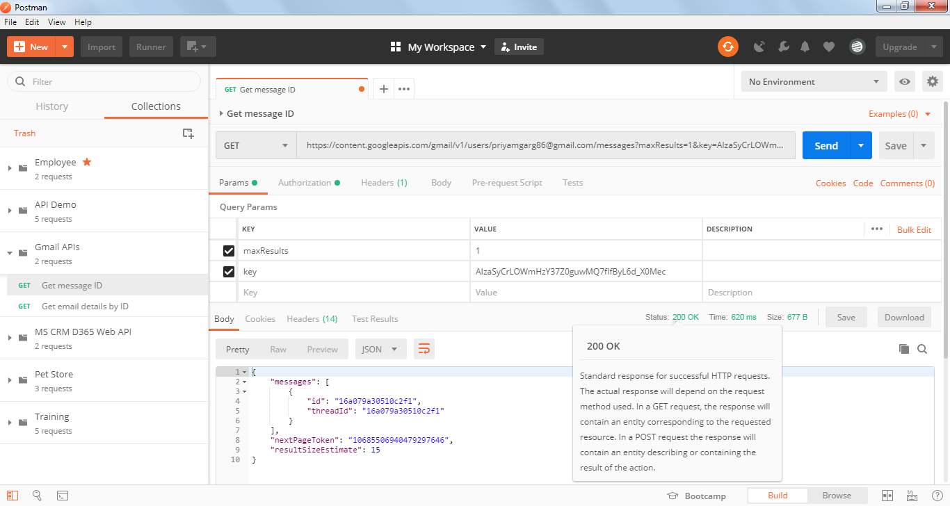

When maxResults is 2 , two message ids are displayed

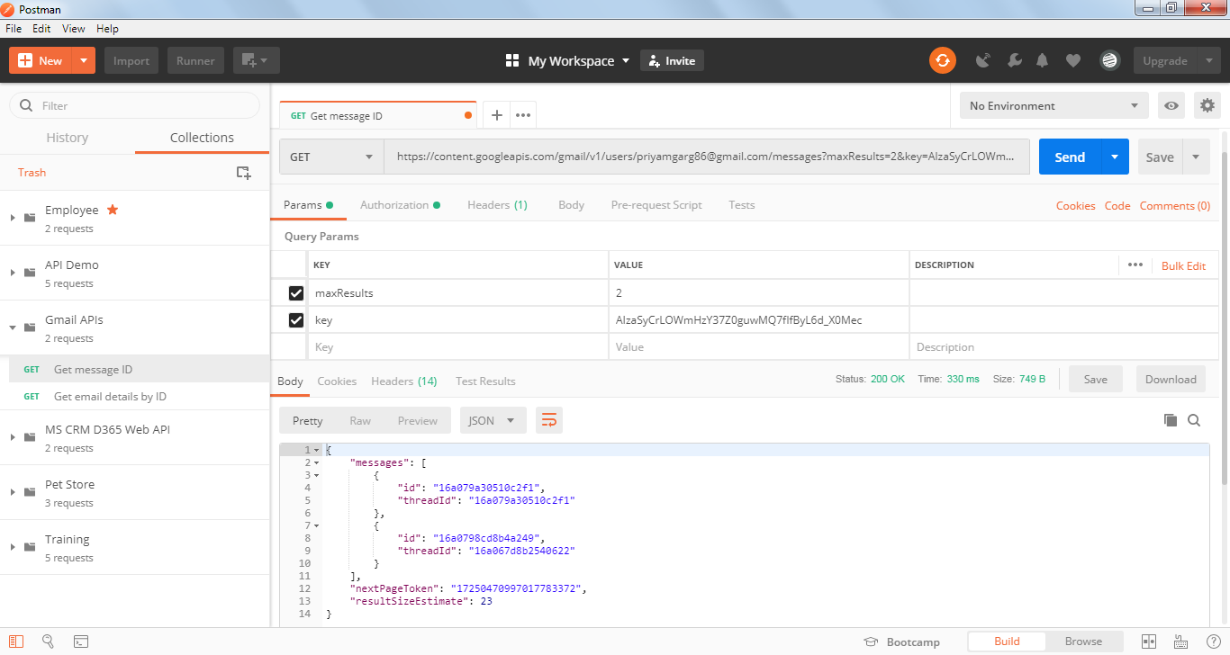

### *Copy parameters to another Postman Request*

Click on Bulk edit

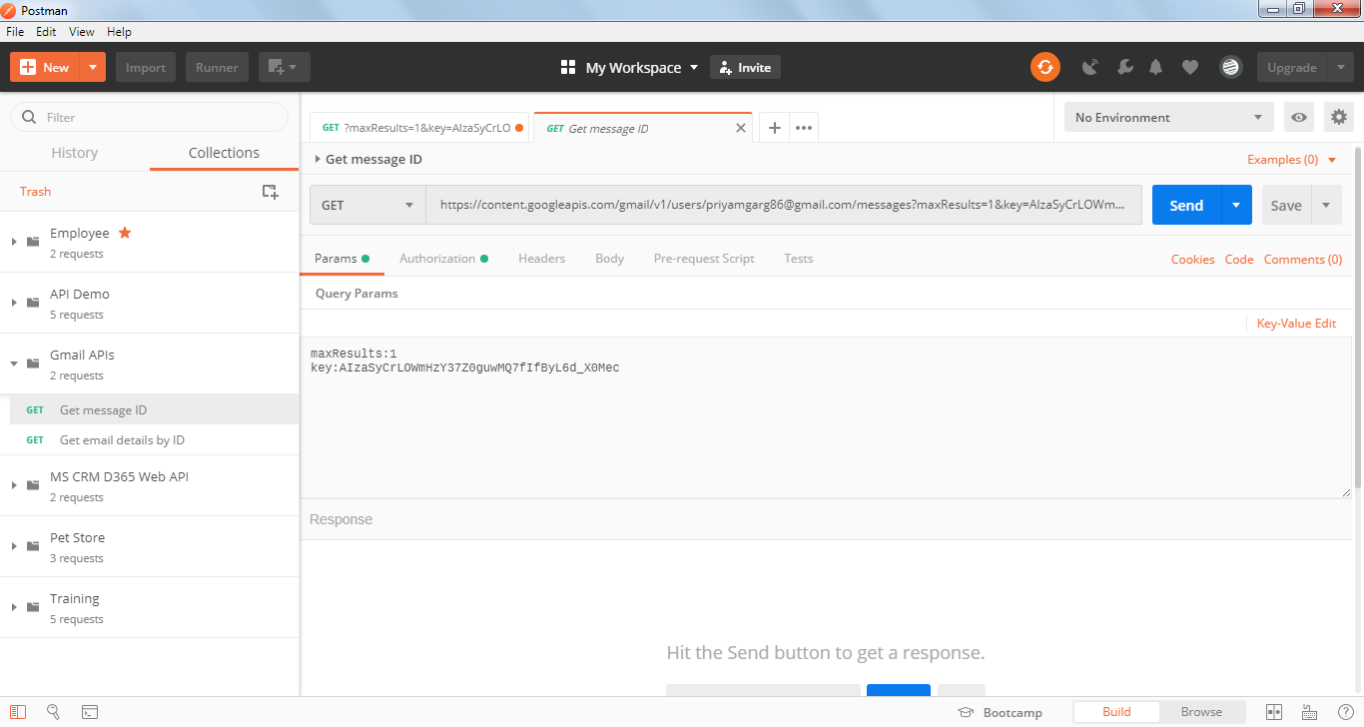

Open a new request and click on Params >> click on Bulk edit

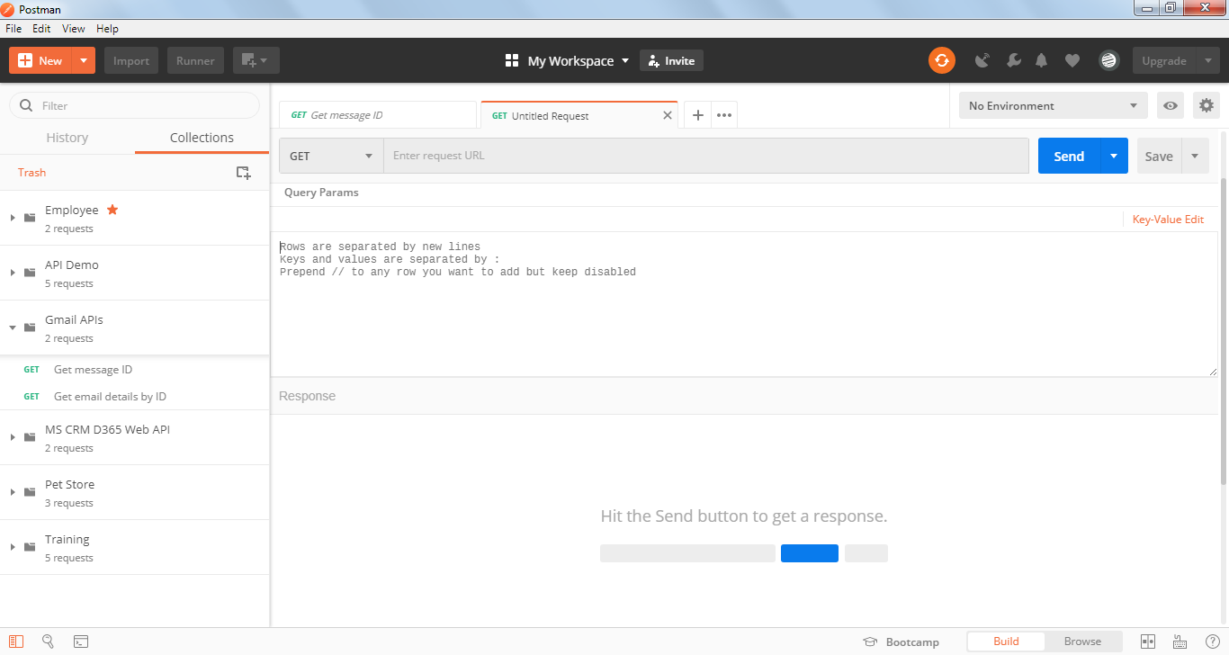

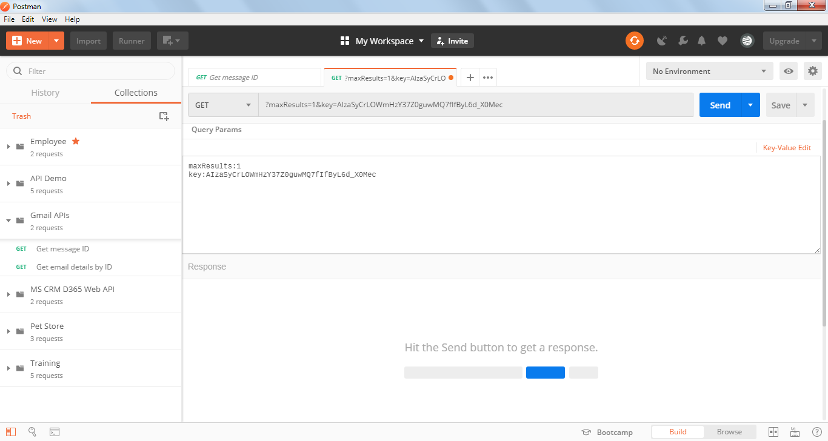

Click on Key Value edit

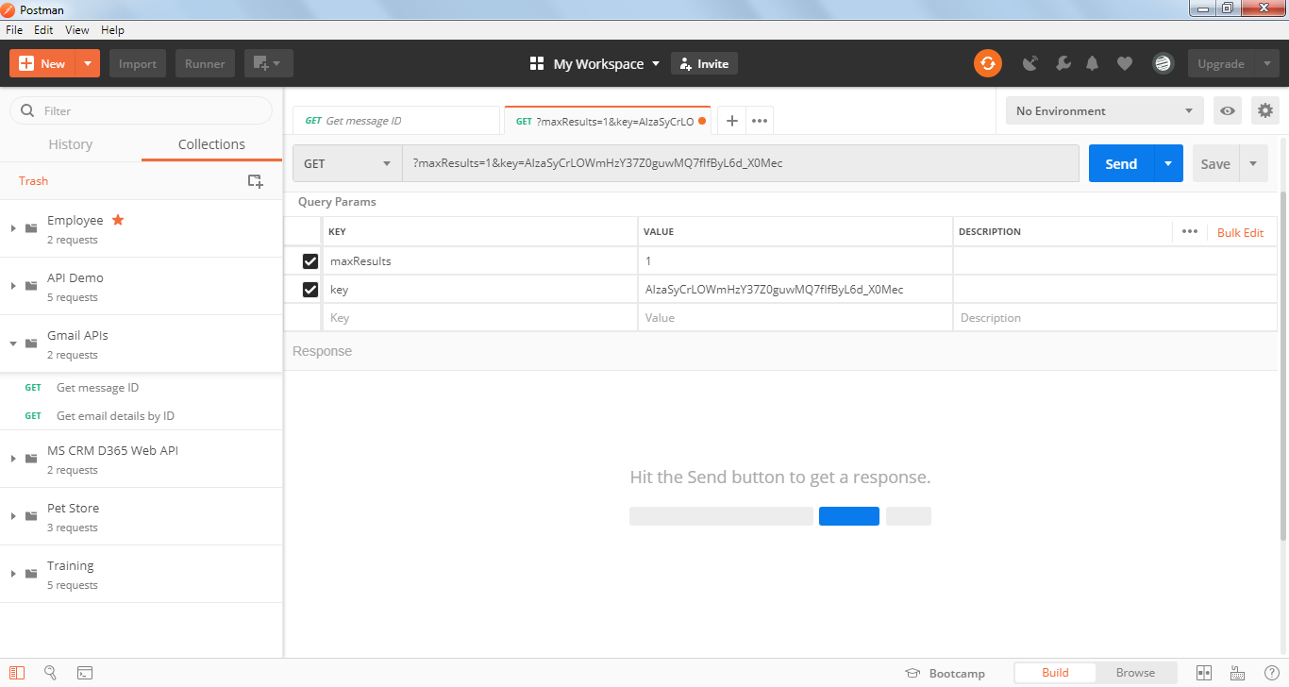

Query Parameters are copied from old request to new request

* Template Parameters

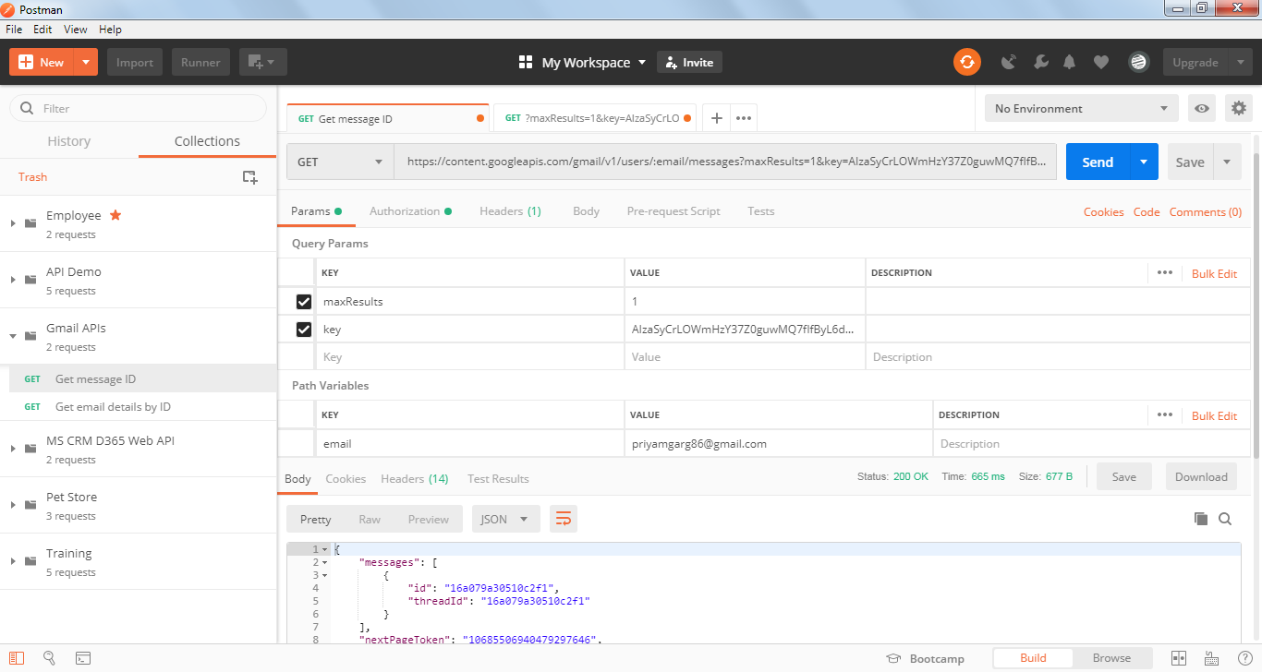

Parameters in the url just before the ‘?’ is called Template Parameter

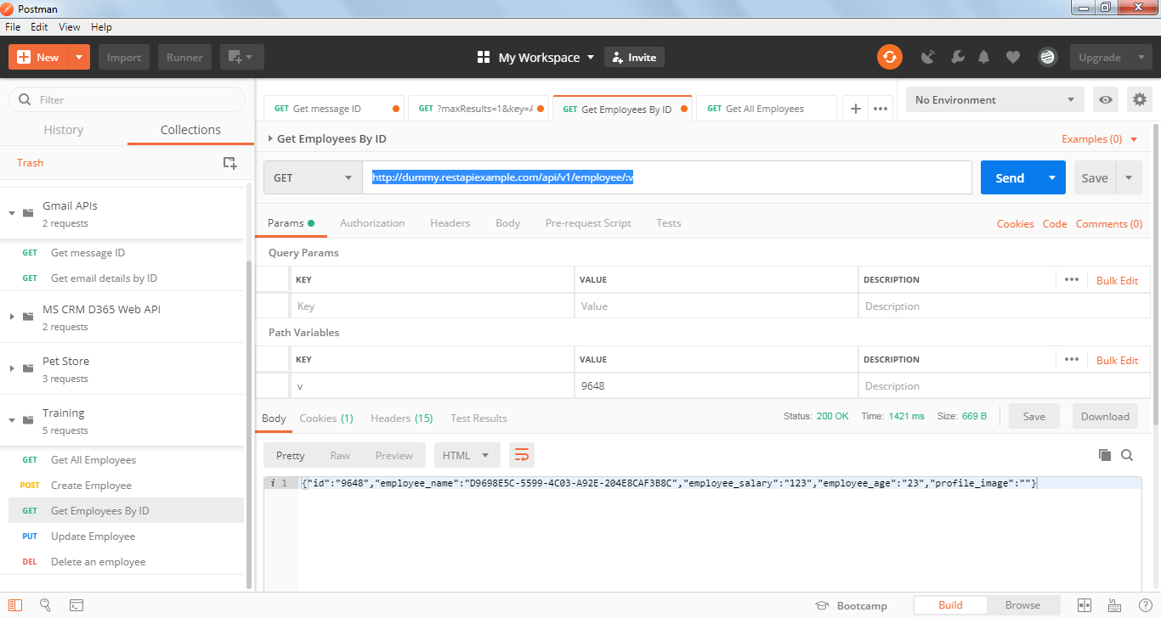

* Matrix Parameter

